

Student Name | Swapnil Birajdar
SRN No | 31231287
Roll No | 41
Program | AIDS
Year | Third Year
Division | A
Subject | Computer Network Laboratory (BTECCE21506)
Assignment No | EIGHT

Assignment Number - 08

Title : DHCP server configuration

Problem Statement : Configuration of DHCP server

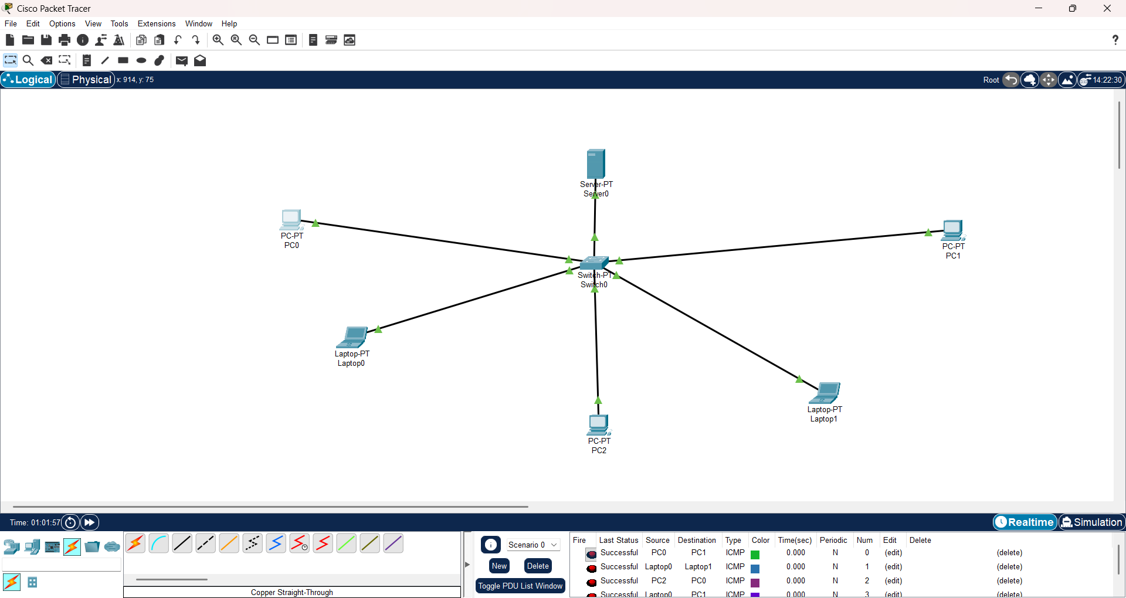
Conclusion : I learnt to configure dhcp server

